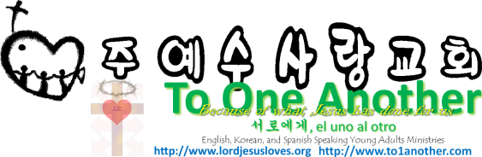
Worshipping in Spirit and in Truth
Pastor Yoo Nam Kang
John 4:23-24
Scriptures in New Living Translation
January 27, 2013

John 4:23-24
23 But the time is coming—indeed it’s here now—when true worshipers will worship the Father in spirit and in truth. The Father is looking for those who will worship him that way. 24 For God is Spirit, so those who worship him must worship in spirit and in truth.”
John 7:37-39
37 On the last day, the climax of the festival, Jesus stood and shouted to the crowds, “Anyone who is thirsty may come to me! 38 Anyone who believes in me may come and drink! For the Scriptures declare, ‘Rivers of living water will flow from his heart.’” 39 (When he said “living water,” he was speaking of the Spirit, who would be given to everyone believing in him. But the Spirit had not yet been given, because Jesus had not yet entered into his glory.)

1. We Worship in Spirit
John 4:24
For God is Spirit, so those who worship him must worship in spirit and in truth.”
John 3:5
Jesus replied, “I assure you, no one can enter the Kingdom of God without being born of water and the Spirit.
1Corinthians 12:3
So I want you to know that no one speaking by the Spirit of God will curse Jesus, and no one can say Jesus is Lord, except by the Holy Spirit.
John 3:16
“For God loved the world so much that he gave his one and only Son, so that everyone who believes in him will not perish but have eternal life.
John 1:12
But to all who believed him and accepted him, he gave the right to become children of God.
1Corinthians 12:3
So I want you to know that no one speaking by the Spirit of God will curse Jesus, and no one can say Jesus is Lord, except by the Holy Spirit.
Matthew 16:16-17
16 Simon Peter answered, “You are the Messiah, the Son of the living God.” 17 Jesus replied, “You are blessed, Simon son of John, because my Father in heaven has revealed this to you. You did not learn this from any human being.

2. We Worship in Truth
Psalms 31:5
I entrust my spirit into your hand. Rescue me, Lord, for you are a faithful God.
John 14:6
Jesus told him, “I am the way, the truth, and the life. No one can come to the Father except through me.
John 16:13
When the Spirit of truth comes, he will guide you into all truth. He will not speak on his own but will tell you what he has heard. He will tell you about the future.
Daniel 10:21
Meanwhile, I will tell you what is written in the Book of Truth. (No one helps me against these spirit princes except Michael, your spirit prince.

3. To Worship in Spirit means we worship out of love
We Worship with the heart of Jesus
John 4:24-25
24 For God is Spirit, so those who worship him must worship in spirit and in truth.” 25 The woman said, “I know the Messiah is coming—the one who is called Christ. When he comes, he will explain everything to us.”
1Corinthians 6:17
But the person who is joined to the Lord is one spirit with him.
Conclusion: Our Lord’s Day gathering is a weekly report of our spiritual battles

So, be filled with Jesus, the Word, Spirit

Give Praise – fruit of our lips
Give Prayer – fruit of our hearts
Evangelize and Give Material Blessings – fruit of our services

And may our worship give glory to God

